**Program to find Greatest among three:**

**public class Num{**

**public static void main(String args[]){**

**int a=20;**

**int b=43;**

**int c=12;**

**if(a>b && a>c){**

**System.out.println("A is Greater");**

**}**

**else if(b>a && b>c){**

**System.out.println("B is Greater");**

**}**

**else{**

**System.out.println("C is Greater");**

**}**

**}**

**}**

**Program To Check the Value is Palindrome Or Not:**

**public class Num{**

**public static void main(String args[]){**

**int st=12321;**

**int rev=0;**

**int digit=0;**

**int str=st;**

**while(st>0){**

**digit=st%10;**

**rev=(rev*10)+digit;**

**st=st/10;**

**}**

**if(rev==str){**

**System.out.println(rev+"_Value is Palindrome");**

**}**

**else{**

**System.out.println(rev+"_Value is not Palindrome");**

**}**

**}**

**}**

**Program to check Number is Armstrong or not:**

**public class Num{**

**public static void main(String args[]){**

**int no=153;**

**int n=no;**

**int sum=0;**

**int digit=0;**

**while(no>0){**

**digit=no%10;**

**sum=sum+digit*digit*digit;**

**no=no/10;**

**}**

**if(sum==n){**

**System.out.println(sum+"_No is Armstrong");**

**}**

**else{**

**System.out.println(sum+"_No is not Armstrong");**

**}**

**}**

**}**

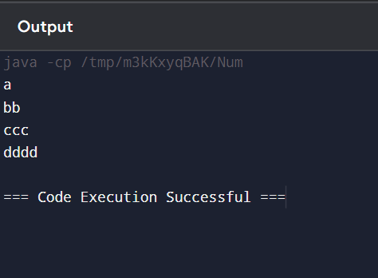

**Program to print following pattern:**

**A**

**BB**

**CCC**

**DDDD**

**public class Num{**

**public static void main(String args[]){**

**char n[]={'a','b','c','d'};**

**for(int i=0;i<n.length;i++){**

**for(int j=0;j<=i;j++){**

**System.out.print(n[i]);**

**}**

**System.out.print("\n");**

**}**

**}**

**}**

**Program to Print Reverse Pyramid:**

**public class Num {**

**public static void main(String[] args) {**

**int n=10;**

**for(int i=0;i<=n;i++){**

**for(int j=0;j<=n;j++){**

**if(j>=i && (i+j)<=n){**

**System.out.print("*");**

**}**

**else{**

**System.out.print(" ");**

**}**

**}**

**System.out.println();**

**}**

**}**

**}**

**Program to print 3 by 3 matrix star**

**public class Num {**

**public static void main(String[] args) {**

**int n=3;**

**for(int i=0;i<n;i++){**

**for(int j=0;j<n;j++){**

**if(i>=0){**

**System.out.print("*");**

**}**

**else{**

**System.out.print(" ");**

**}**

**}**

**System.out.println();**

**}**

**}**

**}**

**Program to print rectangle**

**public class Num {**

**public static void main(String[] args) {**

**int n=4;**

**for(int i=1;i<n;i++){**

**for(int j=0;j<=n;j++){**

**if(i>=0){**

**System.out.print("*");**

**}**

**else{**

**System.out.print(" ");**

**}**

**}**

**System.out.println();**

**}**

**}**

**}**

**Program to print Hollow Square**

**public class Num {**

**public static void main(String[] args) {**

**int n=3;**

**for(int i=0;i<=n;i++){**

**for(int j=0;j<=n;j++){**

**if (i == 0 || j == 0 || i == n || j == n){**

**System.out.print("*");**

**}**

**else{**

**System.out.print(" ");**

**}**

**}**

**System.out.println();**

**}**

**}**

**Program to print Diamond:**

**public class Num {**

**public static void main(String[] args) {**

**int n=10;**

**for(int i=0;i<=n;i++){**

**for(int j=0;j<=n;j++){**

**if((i+j>=n) && (i>=j)){**

**System.out.print("*");**

**}**

**else{**

**System.out.print(" ");**

**}**

**}**

**System.out.println();**

**}**

**for(int i=0;i<=n;i++){**

**for(int j=0;j<=n;j++){**

**if(j>=i && (i+j)<=n){**

**System.out.print("*");**

**}**

**else{**

**System.out.print(" ");**

**}**

**}**

**System.out.println();**

**}**

**}**

**}**

**Program to print Compass:**

**public class Num {**

**public static void main(String[] args) {**

**int n=10;**

**for(int i=0;i<=n;i++){**

**for(int j=0;j<=n;j++){**

**if((i+j>=n) && (i>=j) || j>=i && (i+j)<=n){**

**System.out.print("*");**

**}**

**else{**

**System.out.print(" ");**

**}**

**}**

**System.out.println();**

**}**

**}**

**}**

**Program to print Hollow Compass:**

**public class Num {**

**public static void main(String[] args) {**

**int n=6;**

**for(int i=0;i<=n;i++){**

**for(int j=0;j<=n;j++){**

**if(i==j || i+j==n || i==0 || i==n){**

**System.out.print("*");**

**}**

**else{**

**System.out.print(" ");**

**}**

**}**

**System.out.println();**

**}**

**}**

**}**

**Program to print following pattern:**

**1**

**2 3**

**4 5 6**

**7 8 9 10**

**public class Num{**

**public static void main(String args[]){**

**int n=1;**

**for(int i=0;i<4;i++){**

**for(int j=0;j<=i;j++){**

**System.out.print(n++);**

**}**

**System.out.print("\n");**

**}**

**}**

**}**

**Program for Numeric Triangle**

**public class Num{**

**public static void main(String args[]){**

**for(int i=1;i<5;i++){**

**for(int j=0;j<i;j++){**

**System.out.print(i);**

**}**

**System.out.print("\n");**

**}**

**}**

**}**

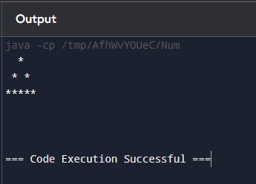

**Program to print hallow full pyramid**

**public class Num {**

**public static void main(String[] args) {**

**int n=5;**

**for(int i=0;i<n;i++){**

**for(int j=0;j<n;j++){**

**if(i==2 || j==n/2+i || j==n/2-i){**

**System.out.print("*");**

**}**

**else{**

**System.out.print(" ");**

**}**

**}**

**System.out.println();**

**}**

**}**

**}**

**Program to Print Inverted Hallow Pyramid**

**public class Num {**

**public static void main(String[] args) {**

**int n=5;**

**for(int i=0;i<n;i++){**

**for(int j=0;j<n;j++){**

**if(i==n/2+j || i+j==6 || i==2){**

**System.out.print("*");**

**}**

**else{**

**System.out.print(" ");**

**}**

**}**

**System.out.println();**

**}**

**}**

**}**

**Program to Print Hallow Diamond**

**public class Num {**

**public static void main(String[] args) {**

**int n=5;**

**for(int i=0;i<n;i++){**

**for(int j=0;j<n;j++){**

**if(i==n/2+j || i+j==6 || j==n/2+i || j==n/2-i){**

**System.out.print("*");**

**}**

**else{**

**System.out.print(" ");**

**}**

**}**

**System.out.println();**

**}**

**}**

**}**